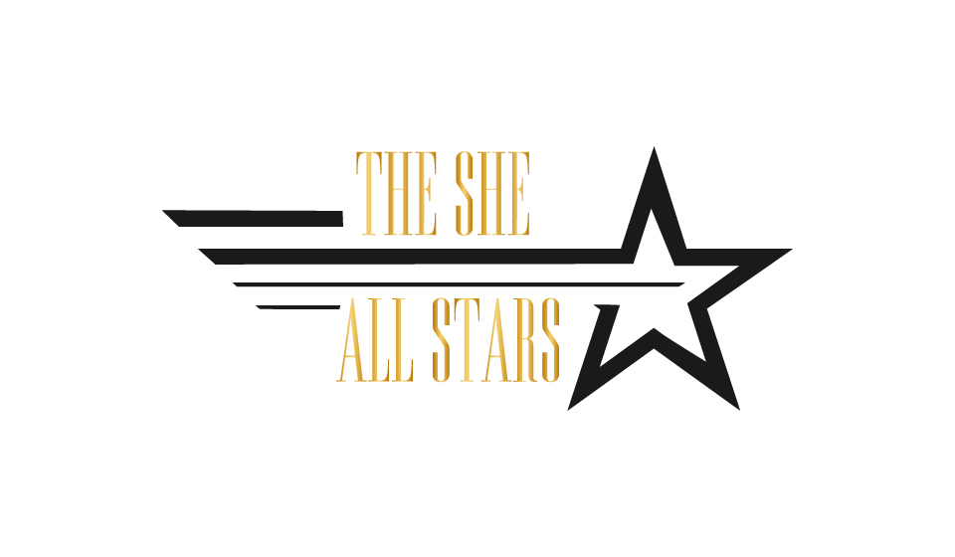
*Sample Set List
2 x 60 Mins

SET 1

- Diamonds – Rihanna
- Ain’t Nobody – Chaka Khan
- Never Too Much – Luther Vandross
- Sing It back – Moloko
- Disco Medley – Le Freak, Get Lucky, Good Times
- Ain’t No Stopping Us Now – Fatback Band
- Kiss – Prince
- Mysterious Girl – Peter Andre
- PYT – Michael Jackson
- No Scrubs – TLC
- THE ESSENTIAL Stevie Wonder Medley
- Word Up – Cameo
- Pull Up To My Bumper – Grace Jones

SET 2

- 24k Magic – Bruno mars
- September – Earth Wind and Fire
- I Wanna Dance With Somebody – Whitney Houston
- Power of Love into Shut Up And Dance– Huey Lewis & Walk The Moon Medley
- No Diggidy - Blackstreet
- Blurred Lines – Robin Thick
- Finally (remix) – Cece Peniston
- Just Dance into Sweet Dreams – Gaga & Eurythmics Medley
- You’ve’ Got The Love – Florence And The Machine
- Sweet Home Alabama - Lynyrd Skynyrd
- Living On A Prayer – Bon Jovi
- Mr Brightside – The Killer
- Simply The Best- Tina Turner
Encore: Crazy In Love
- Please note we have an extensive repertoire and create a bespoke set list for each and every client, but for privacy reasons we do not display our full list on our public website. (we can’t give away all of our secrets ;-)

For our extensive song list, please get in touch! stars@shemusicglobal.com

